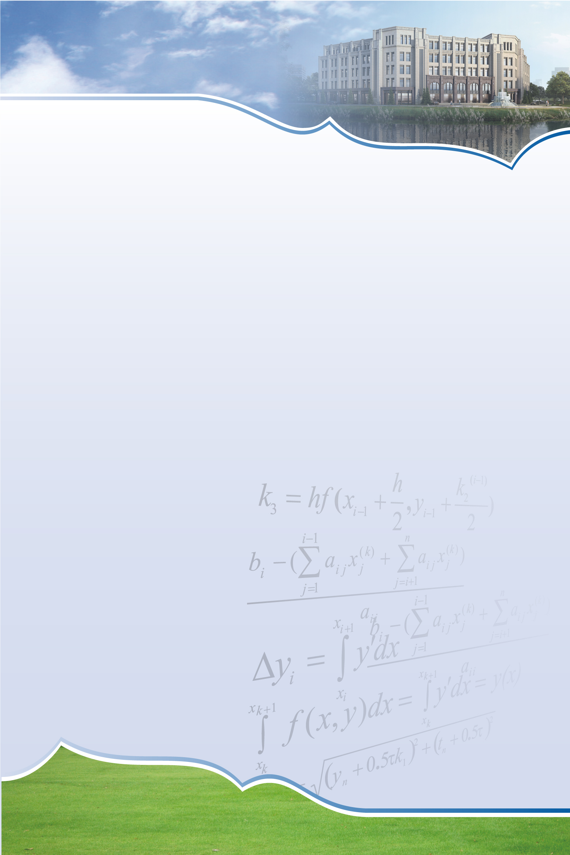
SCMS Seminar

Some topics in complex dynamics

Speaker: Weiwei Cui
Shanghai Center for Mathematical Sciences

Time: 15:30-16:00, Tuesday, June 18, 2019
Venue: Room 2213, East Main Guanghua Tower

Abstract:
In this talk I will discuss the computation of Hausdorff dimension of escaping sets of certain meromorphic functions, the relation between the boundaries of Siegel disks and singular values in the tangent family, and also the construction of rational maps with special branching information. Moreover, some future works will also be mentioned.

Shanghai Center for Mathematical Sciences
No.2005 Songhu Road, Shanghai, China
Tel: 31243880 Fax: 31244000 Postcode: 200438 Email: scms@fudan.edu.cn

