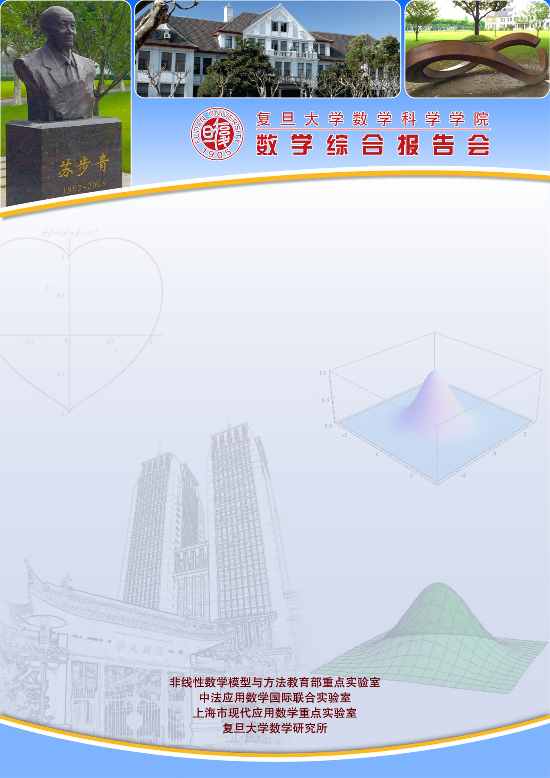
复旦学术前沿论坛
Fudan Academic Frontier Forum

报告题目：An introduction to shape optimization (I)
报告人：Dr. Kei Fong Lam （香港中文大学）
报告时间：2019-03-13 星期三 10:00-11:00
报告地点：光华东主楼1801
摘要：The goal of this short course is to give an introduction in shape optimization with partial differential equations (PDEs). A prominent example is the problem of finding the best shape of an object flowing through a fluid with the smallest drag. We begin with a crash course in mathematical optimization, followed by several results in shape calculus, and finally studying the drag minimization problem. The emphasis of this course is on the methods to compute so-called shape derivatives for shape optimization problems.

支持单位：复旦大学高等学术研究院

