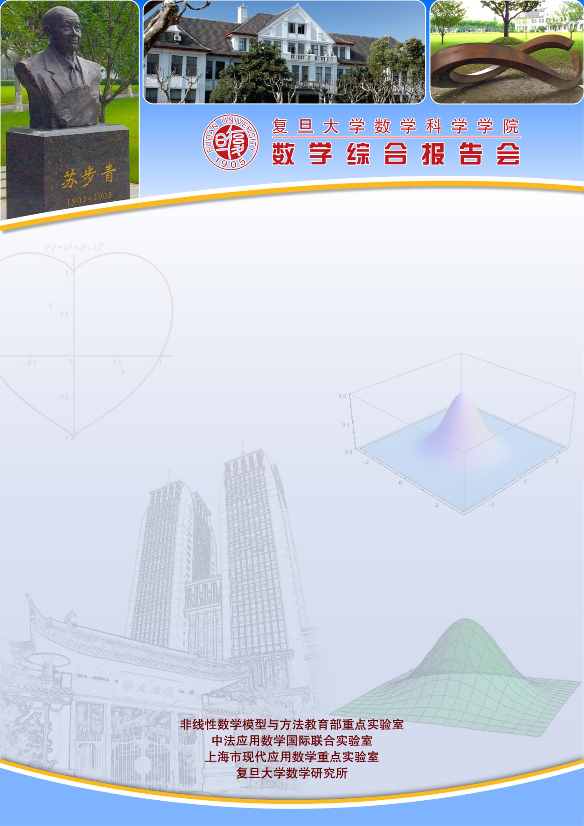
报告题目：Least action principle for incompressible flow with free boundary
报告人： Jian-Guo Liu 博士（Duke University）
时间：2019-03-22 星期五 10:00-11:00
地点： 光华东主楼1801
报告摘要：In this talk I will describe a connection between Arnold's least-action principle for incompressible flows with free boundary and geodesic paths for Wasserstein distance.
The least‐action problem for geodesic distance on the `manifold’ of fluid ‐ blob shapes exhibits instability due to microdroplet formation. Using a conformal map formulation we investigate singularity formation in water-wave dynamics neglecting gravity. A connection with fluid mixture models via a variant of Brenier’s relaxed least‐action principle for generalized Euler flows will also be discussed. This is a joint work with Bob Pego and Dejan Slepcev of CMU and Lei Li of SJTU.

