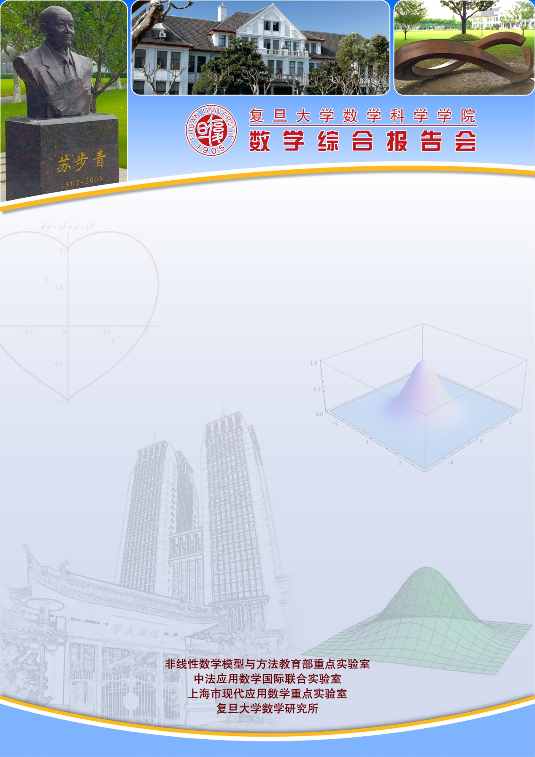
报告题目：No critical nonlinear diffusion in 1D quasilinear fully parabolic Keller-Segel system
报告人： Dr. Kentarou Fujie (Tokyo University of Science)
时间：2019-03-26 星期二 9:30-10:30
地点： 光华东主楼1801
报告摘要：We deal with the fully parabolic 1d chemotaxis system with diffusion $1/(1+u)$. We prove that the above mentioned nonlinearity, despite being a natural candidate, is not critical. It means that for such a diffusion any initial condition, independently on the magnitude of mass, generates global-in-time and bounded solution. In order to prove our theorem, we establish a new Lyapunov-like functional associated to the system. This talk is based on a recent joint project with Tomasz Cieslak.
This talk is based on a joint work with Shi Zhan, Sidoravicius Vladas and Wang Longmin.

